Eduvos Assessment Coversheet
Academic Details
Campus: | Tygervalley
Faculty: | IT (BSc IT Software Engineering)
Module Code: | ITMDA3-B34
Lecturer’s Name: | T. Makhurane
Group (if applicable) | Group 1 (S10)
Assessment Details
Assessment Type: | Formative
Assignment/Brief Number:
Due Date/ Submission Date: | 4 September 2026
Student Details (Group, if applicable)
# | Full Name | Student Number | Contact Number | % Participation | Signature
1 | Nicholas Bence | EDUV4846233 | 0710725884 | 16.67
2 | Chris Esterhuyse | CON-1389312-F7J9 | 0815663533 | 16.67
3 | Marthinus Schoeman | EDUV4898390 | 0604360021 | 16.67
4 | Tertius Roux | EDUV4877151 | 0691581011 | 16.67
5 | Mardo Saayman | EDUV4849144 | 0628798355 | 16.67
6 | Stephan Esterhuizen | EDUV4863668 | 0636169670 | 16.67

Student Details (Individual, if applicable)
Student Full Name:
Student Number:
Academic Integrity
AI Disclosure Completed | Yes | No
Declaration:
I declare that this assessment is my own original work except for source material explicitly acknowledged. I confirm that this work has not previously been submitted for assessments in any course. I acknowledge the institutional AI policy and confirm that AI tools have only been used as stipulated and documented in the AI Disclosure Appendix.

Student Signature
Date

Lecturer Use Only
Lecturer Comments:
Marks Awarded (%):
Lecturer Signature:
Date:

Assessment
Table of Contents
Eduvos Assessment Coversheet 1
Assessment 5
Deliverable 3 – Modeling 6
I. Topic Selection and Use Case Description 6
II. Functional and Non-Functional Requirements 7
III. User Stories or Use Case Narratives 14
IV. Use Case Diagram 14
V. Screen Mockups 15
VI. Architecture Design 21
VII. Data Design 24
Bibliography 36
AI Evidence Section 37
AI Disclosure Appendix 38
Declaration: 38

Deliverable 3 – Modeling

Topic Selection and Use Case Description
Topic:
The project will improve upon the current poor experience of using WebUntis, the timetable system that is used by Eduvos. The system is not optimized for mobile use, is slow to load with no local caching, has no onboarding for new users, Eduvos has not enabled calendar export, so students can't subscribe from a calendar app they already use, and it can't notify students of changes; a change is only visible if someone happens to check.
Users:
One type of user is a student. Two examples of what kind of users the project aims to satisfy include a student with unreliable mobile internet connection, whose timetable needs to be loaded instantly and who should be notified about any changes instead of randomly discovering them; and a student living in a calendar application, wanting lectures to appear there automatically and being notified about cancellations and other changes.
What the system will do:
The application mirrors a student's WebUntis timetable. The account is linked once by scanning a QR code, and the stored credential is then used to poll WebUntis on the student’s behalf. It checks the WebUntis timetable on the scheduled intervals for any changes and sends a notification in case it detects them. The timetable in the application will be displayed offline, as it is cached locally. Beyond mirroring the timetable, the application adds two student-owned features: lesson notes and custom reminder rules. Timetable is also provided in a form of a calendar feed.
Scope:
In: QR account linking, Today/Week views of timetable, offline caching, change detection and push notifications, notes, reminder rules and calendar feed.
Out: administrator-related features, personal events, homework/grades/attendance, social features, email/password account linking.

Functional and Non-Functional Requirements
Functional Requirements

Onboarding & Identity
FR-1. Show an intro explaining what the app does before asking for camera access. This is a must-have requirement, and it's considered done when the intro screen displays before any camera permission prompt appears.
FR-2. Scan a QR code to pull the school, username, and secret needed to link the account. This is a must-have, done when a valid QR code links the account, and an invalid or unreadable code shows an error without crashing.
FR-3. Create a new user, or match an existing one if that WebUntis username was already linked. This is a must-have, done when scanning a QR tied to an already-linked username attaches the new device to the existing account instead of creating a duplicate.
FR-4. Register each device, and its push subscription, to the user's account. This is a must-have, done when the device appears in the user's device list with a valid push token stored after linking.
FR-5. Let the same account be used on multiple devices by scanning the QR code again on each. This is a should-have, done when re-scanning on a second device shows the same timetable data as the first.
FR-6. Explain why notifications are needed before the phone's permission prompt appears. This is a must-have, done when the explanation screen requires a tap before the OS permission dialog fires.
FR-7. Let the user unlink their account, which deletes their stored credentials and data. This is a must-have, done when querying the backend for that user's data after unlinking returns nothing, and the local cache is cleared.
FR-8. Offer an optional biometric or PIN lock before showing timetable data. This is a should-have, done when enabling the lock requires biometric or PIN entry on the next app open, and disabling it removes the requirement.

Timetable Display
FR-9. Show a Today view with the current or next lesson front and centre. This is a must-have, done when the current lesson, if in progress, or otherwise the next lesson, is visually prioritised at the top of the screen.
FR-10. Show a Week view with all lessons for the week. This is a must-have, done when all lessons for the selected week are visible without needing to scroll horizontally.
FR-11. Let the user move between weeks. This is a must-have, done when swipe or arrow navigation loads the adjacent week's data correctly.
FR-12. Show full lesson detail, including subject, lecturer, room, time, status, and change history. This is a must-have, done when tapping a lesson opens a detail view containing all six fields.
FR-13. Load the timetable from local cache instead of requiring a live network request. This is a must-have, done when the timetable is visible within 1 second of launch with the device in airplane mode.
FR-14. Show when the timetable last successfully synced. This is a must-have, done when a "last synced" timestamp is visible on the Today view at all times.
FR-15. Support pull-to-refresh with a loading indicator. This is a should-have, done when the pull gesture triggers a visible spinner and updates data on success.
FR-16. Make cancelled, moved, or newly added lessons visually distinct using colour and an icon or label, not colour alone. This is a must-have, done when each status has a unique icon or label independent of colour, verified with a colour-blindness simulator.

Change Detection & Notification
FR-17. Poll WebUntis regularly on a configurable schedule. This is a must-have, done when the polling interval is read from configuration rather than hardcoded, using a 5-minute interval in production and roughly 30 seconds in demo mode.
FR-18. Compare each poll to the last known state, checking subject, time, room, and status. This is a must-have, done when changing any one of those four fields in the mock service triggers a detected change, while unrelated field changes do not.
FR-19. Limit change detection to a configurable window, defaulting to today through 14 days out. This is a must-have, done when a change made to a lesson more than 14 days out is not recorded, while a change within the window is.
FR-20. Save every detected change as a permanent record. This is a must-have, done when change records persist in the database and are never deleted or overwritten.
FR-21. Send at most one notification per user per polling cycle. This is a must-have, done when triggering five simultaneous changes in one poll cycle results in exactly one push.
FR-22. If one thing changed, name it in the notification. This is a must-have, done when the notification text includes the subject and the nature of the change.
FR-23. If multiple things changed, summarise them instead of sending several notifications. This is a must-have, done when a multi-change notification states a count, such as "3 changes," rather than listing each one.
FR-24. Never notify about the same change twice, even after a server restart. This is a must-have, done when restarting the backend after a notification was sent does not cause that same change to be re-delivered.
FR-25. Hold notifications during quiet hours and send them once quiet hours end. This is a should-have, done when a change detected during quiet hours is delivered at the end of that period rather than immediately.
FR-26. Show a feed of recent changes, most recent first. This is a must-have, done when the Changes tab lists records in descending order by detection time.
FR-27. Send a reminder before each lesson based on the applicable reminder rule. This is a must-have, done when a reminder fires at the lead time specified by the rule that applies to that lesson.

Lesson Notes
FR-28. Let the user add a text note to a specific lesson. This is a must-have, done when a saved note appears attached to the correct lesson.
FR-29. Show all notes on a lesson, plus an indicator when a lesson has one. This is a must-have, done when lessons with at least one note show a visible indicator in the Today and Week views.
FR-30. Let the user edit a note. This is a must-have, done when edited content persists and displays correctly after reopening the lesson.
FR-31. Let the user delete a note, with a confirmation step. This is a must-have, done when delete requires a confirmation tap, and cancelling that confirmation leaves the note intact.
FR-32. Keep a note attached to its lesson even if the lesson's time or room changes. This is a must-have, done when changing a lesson's room or time via the mock service does not detach or delete its note.
FR-33. Validate notes so they can't be empty or over 500 characters, showing the character count. This is a must-have, done when saving is disabled on empty input or input over 500 characters, and the counter updates live.

Custom Reminder Rules
FR-34. Let the user create a reminder rule with a scope, either all lessons, one subject, or one lesson, and a lead time. This is a must-have, done when a created rule is stored with the correct scope and lead time.
FR-35. Let the user view all their reminder rules. This is a must-have, done when the rules list displays every rule the user has created.
FR-36. Let the user edit a rule's scope, lead time, or enabled status. This is a must-have, done when edited values persist and take effect on the next applicable reminder.
FR-37. Let the user delete a rule, with a confirmation step. This is a must-have, done when delete requires confirmation, and a deleted rule no longer appears or fires.
FR-38. When multiple rules could apply to a lesson, use the most specific one, so a lesson-level rule beats a subject-level rule, which beats the global default. This is a must-have, done when overlapping rules are configured and only the most specific one's lead time is used.
FR-39. Validate lead time as a whole number between 0 and 1440 minutes. This is a must-have, done when values outside that range, or non-integer input, are rejected with an error message.

Calendar Integration
FR-40. Provide each user's timetable as a subscribable calendar feed at a private, hard-to-guess link. This is a must-have, done when the feed URL contains a high-entropy token and returns valid calendar data when fetched.
FR-41. Give each lesson a stable ID so a subscribed calendar updates it instead of duplicating it. This is a must-have, done when re-fetching the feed after a change updates the existing calendar event rather than creating a duplicate.
FR-42. Show cancelled lessons as cancelled in the feed, rather than removing them. This is a must-have, done when a cancelled lesson still appears in the feed, marked as cancelled.
FR-43. Show the feed link in Settings with a copy button and subscribe instructions. This is a should-have, done when the feed URL is visible and copyable from the Settings screen.
FR-44. Let the user regenerate the feed link, invalidating the old one. This is a should-have, done when the old feed URL returns an error after regeneration, and the new URL returns valid data.

Settings & Feedback
FR-45. Provide a Settings screen for reminder defaults, quiet hours, notifications, app lock, the calendar link, and unlinking the account. This is a must-have, done when all six controls are present and functional on one screen.
FR-46. Give visible feedback, success or error, whenever a user changes data. This is a must-have, done when every save or update action results in a visible confirmation or error message.
FR-47. Validate input fields on submit and show clear error messages. This is a must-have, done when invalid input produces a field-level error rather than a silent failure.
FR-48. Require confirmation before any destructive action. This is a must-have, done when delete or unlink actions cannot complete without a confirmation step.
FR-49. Show a loading indicator during network requests, with a retry option if one fails. This is a should-have, done when slow or failed requests show a spinner and, on failure, a retry button.
Non-Functional Requirements
NFR-1. The Today view should load from cache in under a second with no network needed. This is a must-have, done when the measured load time from launch to a visible Today view is under 1 second with the network disabled, and cached data is considered stale once 5 minutes have passed since the last successful sync.
NFR-2. The app should stay usable for viewing timetable, notes, and reminders even if the backend is unreachable, and should recover automatically once it's back. This is a must-have, done when the app still displays cached data and functions read-only while the backend is down, and sync resumes automatically within one polling cycle of the backend returning.
NFR-3. A new user should reach a populated timetable in 5 taps or fewer, not counting the QR scan. This is a must-have, done when the tap count from onboarding completion to a visible timetable is confirmed at 5 or fewer.
NFR-4. Stored credentials should be encrypted at rest. This is a must-have, done when direct inspection of the database shows no plaintext credential values.
NFR-5. All communication between the app and server should be encrypted over HTTPS. This is a must-have, done when all API endpoints reject plain HTTP connections.
NFR-6. Calendar feed links should be long, random, and revocable. This is a must-have, done when the feed token has at least 256 bits of entropy and can be invalidated on demand.
NFR-7. The system should only store what it needs, and delete everything on unlink. This is a must-have, done when no user-linked records remain in any table after unlinking.
NFR-8. No more than one notification should be sent per user per polling cycle, to avoid notification fatigue. This is a must-have, verified by the same test as FR-21.
NFR-9. Notifications shouldn't repeat after a server restart. This is a must-have, verified by the same test as FR-24.
NFR-10. The system should support a self-contained local demonstration mode requiring no external accounts, separate from a production mode that does. This is a must-have, done when a single docker compose command with the mock WebUntis data source runs a fully working demo with no internet access needed, while the team's production deployment separately relies on Cloudflare Tunnel for public HTTPS access and Firebase Cloud Messaging for push delivery, both of which do require external accounts.
NFR-11. The data source should be swappable so the system can be tested without live access to the real timetable system. This is a must-have, done when switching a configuration value points the backend at the mock service instead of live WebUntis, with no code changes required.
NFR-12. The app should run on Android and as an installable app on iOS. This is a must-have, done when the app installs and runs core functionality on an Android device, and as a Home Screen PWA on iOS 16.4 or later.
NFR-13. Status should never rely on colour alone, the interface should meet WCAG AA contrast standards, and text should scale with system accessibility settings. This is a must-have, done when contrast ratios meet WCAG AA, status icons remain distinguishable in a colour-blindness simulation, and text resizes correctly when the OS font scale is increased.
NFR-14. Code should be organised into reusable pieces, follow a consistent style, and be commented where the logic isn't obvious. This is a should-have, done when the code passes a linter with the agreed style configuration, and non-trivial functions carry explanatory comments.
NFR-15. The system should support its expected user volume of 6 concurrent users as deployed, without needing a redesign, while remaining architecturally capable of scaling to a full institutional cohort. This is a must-have, done when the system handles 6 concurrent simulated users without errors or unacceptable latency during testing.

User Stories or Use Case Narratives
The narratives below describe how a student interacts with the system to reach their goals. They are grouped according to the same functional areas in the Functional Requirements above. They also give the system coverage the Use Case Diagram on the next page is built from.

Onboarding & Identity
US-1. As a new student, I want to see a short explanation of what the app does before it asks for camera access, so that I understand why the permission is needed before I am asked to grant it.
US-2. As a new student, I want to scan a QR code from WebUntis to link my account, so that I don’t have to type in my school, username, and password by hand.
US-3. As a student, I want to be told why the app needs notification permission before the system prompt appears, so that I can make an informed choice instead of dismissing an unexplained pop-up.
US-4. As a student who no longer wants to use the app, I want to unlink my account, so that my stored credentials and data are permanently deleted.
US-5. As a privacy-conscious student, I want to lock the app behind a PIN, so that someone else picking up my phone can’t see my timetable.

Timetable Display
US-6. As a student, I want to open the app and immediately see my current or next lesson, so that I know where I need to be at a glance.
US-7. As a student planning my week, I want to see all my lessons for the week in one view, so that I can plan around them.
US-8. As a student, I want to swipe between weeks, so that I can check what my timetable looked like or will look like without waiting for it to reload.
US-9. As a student, I want to tap a lesson to see its subject, lecturer, room, time, status, and change history, so that I have all the detail I need in one place.
US-10. As a student, I want to see when the timetable last synced successfully, so that I know how current the information in front of me is.
US-11. As a student, I want to pull down to refresh the timetable manually, so that I can check for updates immediately instead of waiting for the next scheduled sync.
US-12. As a student, I want cancelled, moved, or newly added lessons to be visually distinct using both colour and an icon or label, so that I can tell them apart.

Change Detection & Notifications
US-13. As a student, I want the app to automatically check WebUntis for changes on a regular schedule and remember everything it detects, so that I do not have to refresh manually to find out if something has changed.
US-14. As a student, I want to receive a push notification when my timetable changes, so that I find out immediately instead of discovering it by chance.
US-15. As a student, I want a notification about a single change to clearly state what changed, so that I know exactly what happened without opening the app.
US-16. As a student, I want to be confident I won’t be notified about the same change twice, even if the server restarts, so that I can trust the notifications I get.
US-17. As a student, I want to view a feed of recent changes with the most recent first, so that I can catch up on anything I missed.
US-18. As a student, I want to receive a reminder before each lesson based on whichever reminder rule applies to it, so that I don’t lose track of time and arrive late.

Lesson Notes
US-19. As a student, I want to add a text note to a specific lesson, so that I can jot down something I need to remember about that class.
US-20. As a student, I want to see all my notes on a lesson, with an indicator when a lesson has one, so that I can tell which lessons I have left notes on.
US-21. As a student, I want to edit an existing note, so that I can update it as things change.
US-22. As a student, I want to delete a note after confirming I want to, so that I don’t lose a note by accident.
US-23. As a student, I want my note to stay attached to its lesson even if the lesson’s time or room changes, so that I do not lose context when WebUntis moves a class.

Custom Reminder Rules
US-24. As a student, I want to create a reminder rule scoped to all lessons, one subject, or one specific lesson, with a lead time I choose, so that I get reminded exactly when it’s useful to me.
US-25. As a student, I want to view all the reminder rules I have created, so that I can see what is currently configured.
US-26. As a student, I want to edit a rule’s scope, lead time, or enabled status, so that I can adjust it as my needs change.
US-27. As a student, I want to delete a rule after confirming, so that I do not lose one by mistake.
US-28. As a student with overlapping rules, I want the most specific rule to take priority, so that a rule I set for one lesson isn’t overridden by a general rule.

Calendar Integration
US-29. As a student who uses a calendar app, I want to subscribe to my timetable as a calendar feed, so that my lessons appear automatically alongside the rest of my schedule.
US-30. As a student subscribed to the feed, I want a changed lesson to update the existing calendar event instead of creating a new one, so that my calendar does not fill up with duplicate entries.
US-31. As a student, I want cancelled lessons to still appear in my calendar feed marked as cancelled, rather than silently disappearing, so that I understand why a gap has opened up in my schedule.
US-32. As a student, I want to find and copy my calendar feed link from Settings, so that I can subscribe to it from whichever calendar app I use.
US-33. As a security-conscious student, I want to regenerate my feed link and invalidate the old one, so that I can revoke access if I ever shared it by mistake.

Settings & Feedback
US-34. As a student, I want a single Settings screen for my reminder defaults, notifications, app lock, and calendar link, so that I don’t have to hunt through the app to manage my preferences.
US-35. As a student, I want visible confirmation or an error message whenever I change something, so that I know whether my action actually worked.
US-36. As a student, I want invalid input to show a clear, field-level error when I submit, so that I know exactly what to fix.
US-37. As a student, I want to be asked to confirm before any destructive action, such as deleting a note or unlinking my account, so that I don’t lose something by accident.

Use Case Diagram
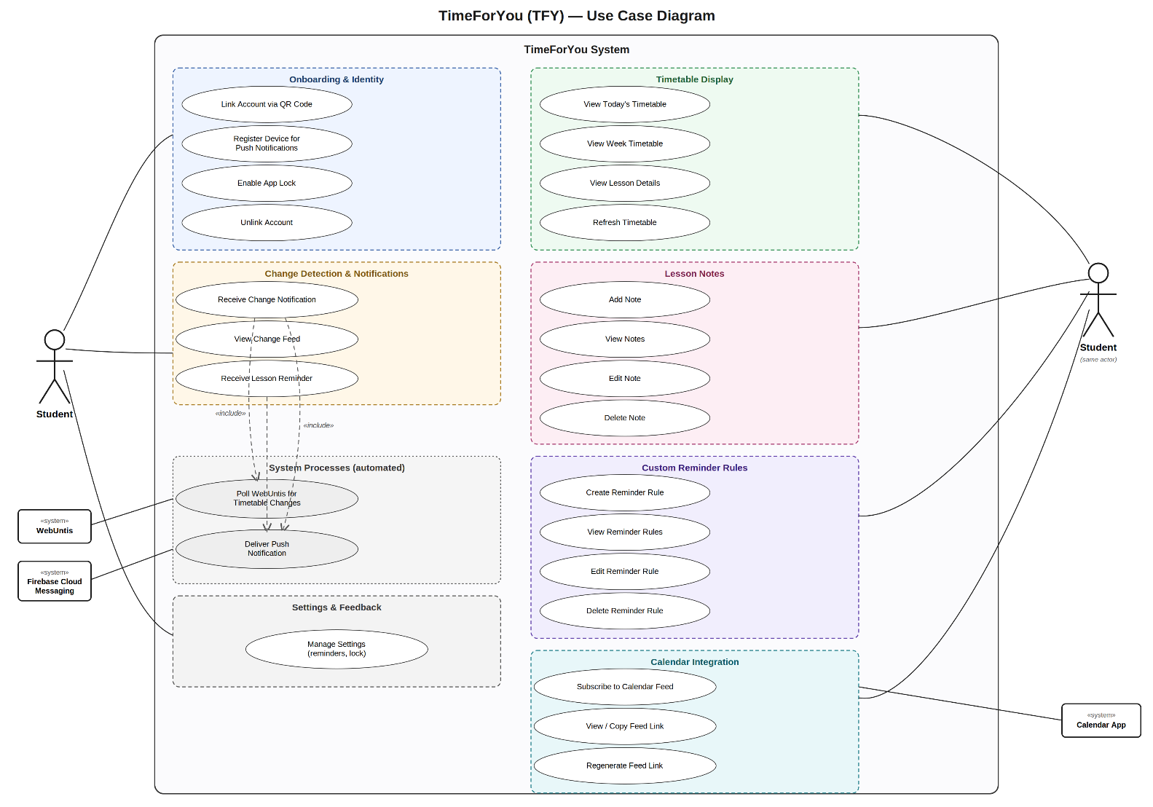
The diagram below groups TimeForYou’s use cases under the same seven functional areas used in the Functional Requirements and the User Stories inside a system boundary. The actor is drawn on both sides of the boundary. This is only to keep the association lines readable, both figures represent the same Student actor. Three external systems appear as supporting actors, namely WebUntis which the platform polls for timetable data, Firebase Cloud Messaging which delivers push notifications, and the student’s own calendar application which pulls the subscribable calendar feed.

The two use cases under System Processes have no direct student action attached to them as they run automatically on a schedule. The include arrows show that receiving a change notification always involves polling WebUntis and delivering a push notification, and that receiving a lesson reminder always involves delivering a push notification.

Screen Mockups
First startup screen. User can link their accounts to get started.
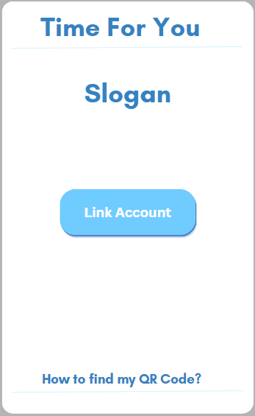

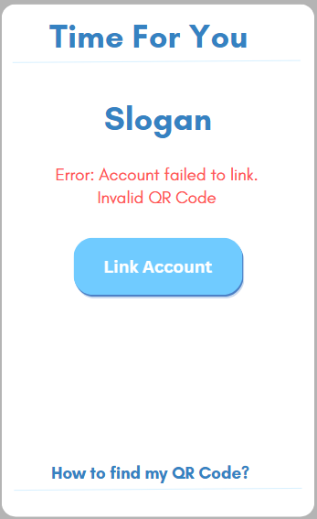
Users will be tasked with scanning a QR code to sign in. If the user has a valid QR code, they get sent to the main page. If not, they will get a small error message, suggesting they should try again, or find their valid QR code.
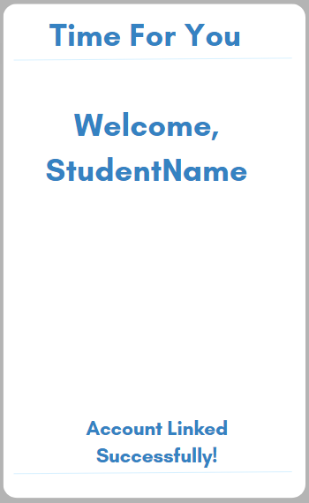

In the home view, users can see the lessons they have on that day, including the lesson details. Users can also click on other days of the week to see what their lessons will look like on those days. Users will have the ability to view each lesson’s details, as well as add a reminder to notify them of the lesson or even notes for the specific lesson
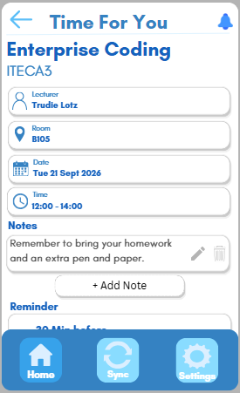
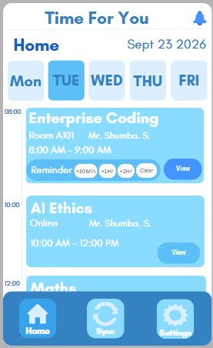
Users will also be able to sync their iCalendars with their current schedules.
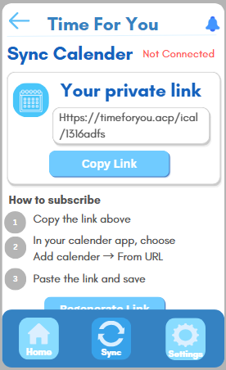
A settings view will also be available, where users can customize their experience and enable or disable features.
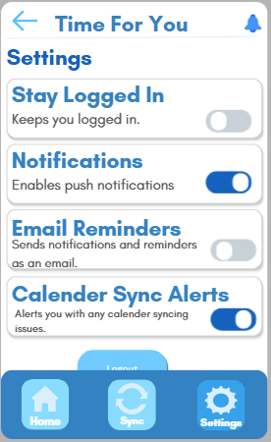
Users will receive push notifications and have a page to view missed notifications or clear them.
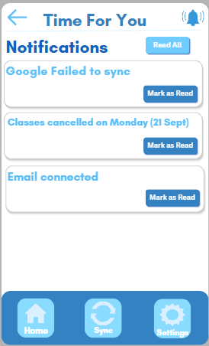

Architecture Design
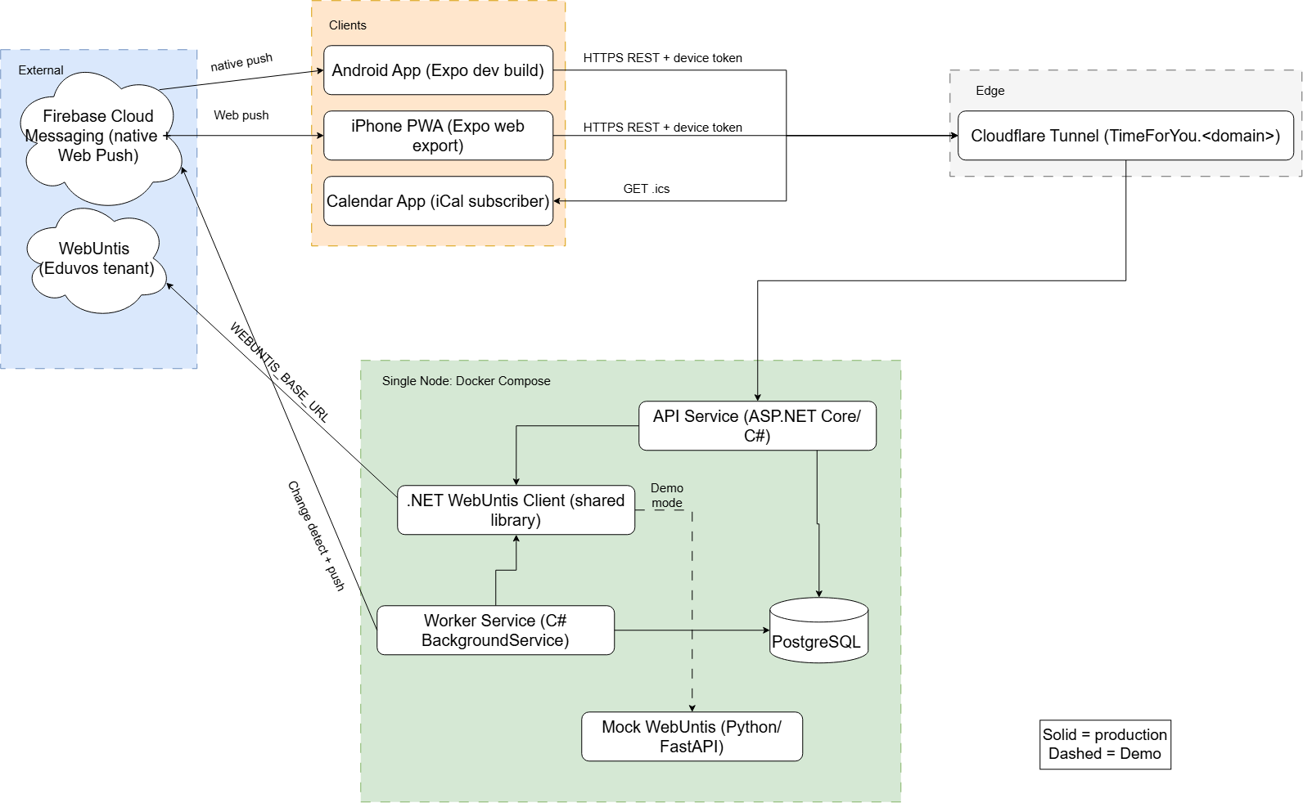
Overview
TimeForYou (TFY) is designed as a small set of services running together on a single host, fronted by a stable HTTPS endpoint and connected to two external systems. The architecture diagram above shows the full picture: three client applications on the top, one edge component providing public access, five services running inside a shared Docker environment, and two external systems the platform depends on. This section walks through each part, the technology preferences behind it, and how the pieces communicate

Components
The system is organised into four logical groups:

Clients covers everything the end user or their tools interact with directly. The Android application is built with Expo. This allows the team to work in a single React Native codebase and produce a native Android build. The iPhone client is produced from the same codebase as an installable Progressive Web App, which lets it run on iOS without requiring a paid Apple Developer Program membership. A third client is the user’s own calendar application, which reads the user’s timetable directly from the backend when the user chooses to subscribe.
Edge contains a single component. A Cloudflare Tunnel is used to expose the backend on a stable public domain without requiring the host machine to have an open inbound port. This makes the backend reachable from the internet, which is required for the mobile app to reach it, for the calendar feed to be subscribable, and for the Progressive Web App to install correctly on iOS.
Single Node: Docker Compose is where most of the system lives. All backend services run together in a Docker Compose environment so the entire stack can be started with a single command. This is important both for the team’s own development and the marker, who must be able to run the full system without needing access to Eduvos infrastructure. Inside this environment there are five components. The API Service, written in ASP.NET Core with C#, exposes the REST endpoints the mobile application calls to login, read timetable data, and manage notes and reminder rules. The Worker Service, also written in C# is a background service. It is responsible for the scheduled work: polling WebUntis for each user, comparing what it retrieves against what is already stored, and sending push notifications when it detects a change. The .NET WebUntis Client is a shared library used by both the API and the Worker, containing the logic for authenticating against WebUntis and retrieving timetable data. PostgreSQL is the persistent data store for all users, timetables, and change-history data. Finally, the Mock WebUntis service, written in Python using FastAPI, provides a stand-in for the real WebUntis system when the platform is being demonstrated or tested without live institutional access.
External contains the two systems the platform depends on but does not run. WebUntis is the source of truth for timetable data and is queried by the .NET WebUntis Client in normal operation. Firebase Cloud Messaging is the delivery channel for all push notifications, handling both native push to Android devices and Web push to the iOS Progressive Web App.

Technology preferences
The technology choices shown on the diagram are current preferences and will be reviewed as the project progresses. The team has selected C# and ASP.NET Core for the primary backend services to keep the API and Worker in a single language and solution. Python was retained for the Mock WebUntis service specifically because FastAPI makes it straightforward to build a small, self-contained mock. PostgreSQL was chosen over hosted alternatives because it can run inside the same Docker Compose environment as the rest of the stack, keeping the team’s development environment identical. Expo and React Native were chosen for the mobile application because a single codebase can target both Android and the iOS Progressive Web App, and because Expo simplifies the process of producing installable builds. Cloudflare Tunnel was selected to provide stable HTTPS access to a self-hosted backend without exposing the host machine directly.

Communication between components
The device token is generated by the API service when the user first links their account by scanning the WebUntis QR code. A random 256-bit value is issued to the app and stored securely on the device using Expo SecureStore. There is also only a hashed version retained in the database against the device record. On every subsequent request the API hashes the incoming token and looks it up to identify the device. The token does not expire on a schedule; it remains valid until the user unlinks their account, at which point the database record is deleted, and the token is immediately invalidated.
The Calendar App interacts with the backend differently: it periodically issues a plain GET request for the user’s iCalendar feed at a unique, unguessable URL, and the backend responds with the current state of the user’s timetable in standard iCalendar format.
Inside the Docker Compose environment, the API Service and the Worker Service both read from and write to PostgreSQL directly. Both services also use the .NET WebUntis Client as a shared library, calling into it whenever they need to talk to WebUntis. The WebUntis Client itself is configured via an environment variable to point at either the real WebUntis systems or the Mock service. It thus, allows the team to switch between live and demo modes without any code changes.
The chosen architecture carries several known limitations. The system runs on a single node with no redundancy, and the PostgreSQL instance is not replicated or backed up on a schedule. Changes in WebUntis are only reflected after the next poll cycle rather than in real time, and WebUntis rate limits are not currently handled. The platform also depends on Firebase Cloud Messaging for notification delivery, which introduces a third-party dependency the team does not control. These limitations are acceptable at the current project scale but would need to be revisited before any production deployment.
Infrastructure considerations and decisions
Several infrastructure choices shape the architecture and are worth noting.
Running the entire backend inside a single Docker Compose environment was a deliberate decision. It keeps the team’s development environment identical, and it eliminates the setup friction that would come with using multiple hosted services. A single command starts the API, Worker, WebUntis Client, database, and mock service together.
Cloudflare Tunnel was chosen because it provides a stable public HTTPS endpoint without requiring the host machine to have a public IP address or open inbound ports. This is important because the mobile application, the calendar feed subscription, and the iOS Progressive Web App installation all require HTTPS access to the backend.
The .NET WebUntis Client is deliberately structured as a shared library rather than a separate service. Because both the API and the Worker need to call WebUntis, and because they both run inside the same Docker Compose environment, splitting the client into its own service would introduce a network boundary and a serialisation contract without providing a benefit at the project’s scale.
The Mock WebUntis service is included as a first-class part of the architecture, not an afterthought. It allows the platform to be demonstrated end-to-end without access to Eduvos infrastructure and makes the change-detection pipeline testable in isolation.
Finally, a small number of decisions are still open and will be finished as implementation proceeds. These include the exact strategy for handling temporary WebUntis outages during poll cycles and the specific mechanism used to configure the sync interval.

Data Design
Overview:
TimeForYou uses a relational database in PostgreSQL, running in the same Docker Compose environment as the rest of the backend. A lesson belongs to a user and a subject, occupies one or more rooms, accumulates changes over time, and may carry user-authored notes and reminder rules – the entities are highly interrelated. Since the system’s core value is detecting that a lesson has moved and notifying the user about it exactly once, the change history is itself a product feature rather than incidental logging. A document-oriented model was considered and rejected: the dominant access patterns require joins across users, lessons, changes and notifications rather than retrieval of self-contained documents. As shown in the entity-relationship diagram below, the model comprises twelve entities.

ERD Diagram:
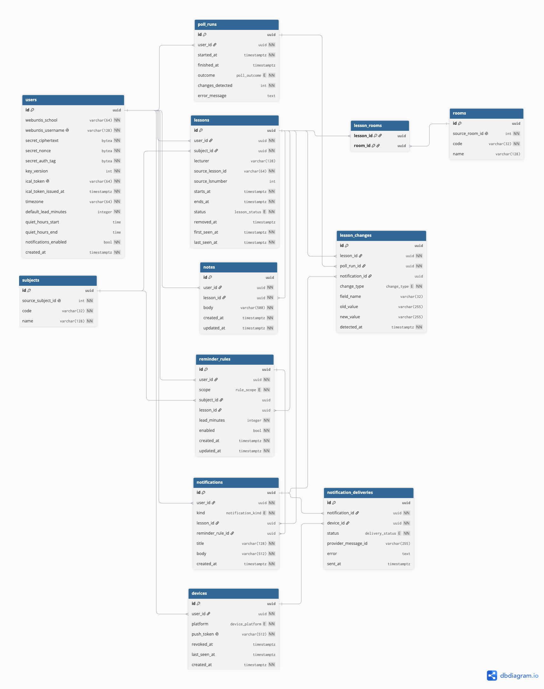
Entity Descriptions:
ENTITY | DESCRIPTIONS
users | One WebUntis identity linked, encrypted credentials, and the user's notification preferences.
devices | A registered device and that device's push address, one user may register more than one device.
subjects | A subject as defined by WebUntis.
rooms | A room as defined by WebUntis.
lessons | Current state of knowledge about one timetable lesson for one user
lesson_rooms | This is a junction table that resolves the many-to-many relationships between rooms and lessons.
poll_runs | Runs one check of WebUntis for a single user, detects any changes and how many changes when found.
lesson_changes | Difference detected between the previous and the current lessons.
notes | Text attached to a lesson that is authored by a User
reminder_rules | Reminder scope and lead time defined by the user.
notifications | One logical push message.
notification_deliveries | Single attempt to deliver that message to a single device.

KEY CONSTRAINTS:
CONSTRAINTS | APPLIED TO | REQUIREMENT THAT IS SUPPORTED
Body non-empty, maximum 500 characters | notes | Notes cannot exceed 500 characters or be empty
lead_minutes between 0 and 1440 | reminder_rules | Lead times must be a whole number between 0 and 1440 minutes
Exactly one target per scope: global rules leave subject_id and lesson_id null; subject rules set subject_id, lesson rules set lesson_id | reminder_rules | A rule may apply to all lessons, a specific subject or a specific lesson.
Unique webuntis_username | users | A new user is created, or an existing one matched, if the username was already linked
Unique push_token | devices | Each device and its push subscription is registered to a single account
Unique on (user_id, source_lesson_id) | lessons | Each poll is compared to the last known state of that same lesson
(user_id, lesson_id, reminder_rule_id) unique where kind = 'reminder' | notifications | A reminder is never sent twice for the same lesson and rule
Unique ical_token, a minimum of 256 bits of entropy | users | The calendar feed link is long, random and revocable.

These four columns on users support encrypted credentials: secret_ciphertext, secret_nonce, secret_auth_tag and key_version.

RELATIONSHIPS AND CARDINALITY:
PARENT | CHILD | CARDINALITY
users | devices | 1: N
users | lessons | 1: N
users | notes | 1: N
users | reminder_rules | 1: N
users | notifications | 1: N
users | poll_runs | 1: N
subjects | lessons | 1: N
subjects | reminder_rules | 1: N
lessons | lesson_rooms | 1: N
rooms | lesson_rooms | 1: N
lessons | lesson_changes | 1: N
lessons | notes | 1: N
lessons | reminder_rules | 1: N
lessons | notifications | 1: N
reminder_rules | notifications | 1: N
poll_runs | lesson_changes | 1: N
notifications | lesson_changes | 1: N
notifications | notification_deliveries | 1: N
devices | notification_deliveries | 1: N

This model’s only many-to-many association is between lessons and rooms, resolved by the junction table lesson_rooms: a room hosts many lessons and a lesson can occupy more than one room. The subjects and rooms tables are keyed on their WebUntis identifiers and are shared across all users rather than scoped per user. This is correct for a single institution and follows from the decision to support one WebUntis tenant; multi-institution support would require these identifiers to be scoped by tenant.

REQUIREMENT TRACEABILITY:
REQUIREMENTS | TRACEABILITY
Onboarding and Identity
Intro screens before camera access | No persistence
Scan QR to pull school, secret and username | users.webuntis_school, .webuntis_username, .secret_ciphertext, .secret_nonce, .secret_auth_tag
Match an existing user or create a new one | Unique users.webuntis_username
Register each device and push subscriptions | devices.platform, .push_token
One account across multiple devices | devices.user_id — one-to-many
Notification permission explained | No persistence
Deleting credentials and unlinking an account | From users ON DELETE CASCADE
Biometric PIN or lock | Local to device, no persistence
Timetable Display
Today View | lessons, indexed on (user_id, starts_at)
Week View | lessons, same index
Moving between weeks | lessons.starts_at
Lesson detail with change history | lessons joined to lesson_changes
Load from local cache | No server-side persistence
Last successful sync | poll_runs.finished_at where outcome = 'success'
Pull to refresh | poll_runs
Distinguishing cancelled, moved, or added lessons | lessons.status, lesson_changes.change_type
Change Detection and Notification
Poll on configurable schedule | poll_runs
Comparing the subject, time, room and status | lessons.subject_id, .starts_at, .ends_at, .status, lesson_rooms
Limit change detection to a window | lessons.starts_at
Save every change permanently | lesson_changes
One notification per polling cycle at most | One notifications row per poll_run
Name the change when only one thing changed | notifications.title, .body; lesson_changes.old_value, .new_value
Summarise when several things changed | Many lesson_changes linked to one notifications row
Even after a restart never send notifications of the same thing twice | lesson_changes.notification_id IS NULL
During quiet hours, hold notifications | users.quiet_hours_start, .quiet_hours_end, .timezone
Provide a feed of any recent changes | lesson_changes grouped by poll_run_id
Reminders before each lesson | notifications where kind = 'reminder', joined to reminder_rules
Lesson Notes
Add, view, edit and delete notes | notes
Note remains attached through changes in class time or place | notes.lesson_id retained; lessons.removed_at tombstone
Maximum 500 characters, and validated non-empty. | notes.body
Custom Reminder Rules
Create a rule with scope and a lead time | reminder_rules.scope, .subject_id, .lesson_id, .lead_minutes
Perform actions such as deleting, viewing, editing and adding rules | reminder_rules
Be able to enable and disable the rules | reminder_rules.enabled
The most specific rule prevails | reminder_rules.scope
Validate that a lead time is a whole number and stays between 0 and 1440 minutes | reminder_rules.lead_minutes
Calendar Integration
Subscribe feed through a private URL | users.ical_token
Stable lesson ID so the calendar updates the event instead of duplicating it | lessons.id
Show the cancelled lessons as cancelled | lessons.status, .removed_at
Be able to show the link in settings | No persistence
Be able to regenerate the feed link | users.ical_token, .ical_token_issued_at
Settings and Feedback
Settings for reminders, quiet hours, notifications, app lock and feed link. | users
Feedback, validation, confirmation and loading states | No persistence

DATA-MODEL-RELEVANT NFR TRACEABILITY
Only these four below, out of the fifteen non-functional requirements listed and define in Functional and Non-Functional Requirements, are supported directly by the data model, the remainder are addressed by the client implementation, the system architecture, and by the interface design rather than by the schema itself.
NON-FUNCTIONAL REQUIREMENTS | SUPPORTED BY
Credentials must be encrypted at rest | users.secret_ciphertext, .secret_nonce, .secret_auth_tag, .key_version
Calendar feed link is long, random and revocable. | users.ical_token
Delete everything on unlink and store only what is needed. | ON DELETE CASCADE
After a restart the notifications should not be repeated | lesson_changes.notification_id with the uniqueness constraint on notifications

LESSON IDENTITY ASSUMPTION
The schema matches each polled lesson to its stored row on UNIQUE (user_id, source_lesson_id), where source_lesson_id is the WebUntis period identifier. Whether that identifier survives an edit is not documented by Untis and has not been confirmed by Eduvos. It also cannot be determined from existing data, because Eduvos timetables in practice see lessons moved rather than cancelled, so the behaviour will only become observable once a real move occurs during a polling period.

This is therefore treated as a question to be resolved during implementation rather than assumed away. Raw poll responses are retained so that the first observed move can be examined after the fact, and lesson matching is isolated behind a single interface with two implementations: the current one keyed on the period identifier, and a fallback keyed on a composite of (user, date, period, subject). Switching between them is a configuration change rather than a redesign, because notes, reminder rules and change records all reference the internal lessons.id and never the WebUntis identifier. Should a move prove to be recorded as a cancellation plus an addition, the two periods will share an lsnumber – the WebUntis teaching-unit number, already stored as lessons.source_lsnumber – allowing the pair to be correlated and reported as a single move, as FR-22 requires.

The schema therefore supports every functional requirement defined in the Functional and Non-Functional Requirements section, together with the four non-functional requirements that are dependent on the data model, whether by a table, a column or a constraint. The requirements marked as having no persistence are interface behaviours implemented in the client – deliberate exclusions, not omissions from the data model.

Bibliography

AI Evidence Section

AI Disclosure Appendix
AI tool used | Purpose / how it was used | How I verified or adapted the output

Declaration:
I/we declare that this assessment is my/our own original work, except for source material explicitly acknowledged. I/we confirm that any use of Artificial Intelligence (AI) tools has been applied only as permitted by the assessment instructions and has been fully disclosed where required.
I/we understand that I/we remain responsible for the accuracy, originality, and academic quality of this submission. I/we am/are aware of the institution’s policies on academic integrity and the requirements relating to the responsible use of AI in assessments.
I/we acknowledge that failure to comply with these requirements, including undeclared or inappropriate AI use, may result in academic penalties or disciplinary procedures in accordance with institutional policy.

Student Signature(s) | Date
 | 4 September 2026
 | 4 September 2026
 | 4 September 2026
 | 4 September 2026
 | 4 September 2026
 | 4 September 2026

